

Improving success in telemarketing: An application of statistical methods in the banking industry
by
Dimpho Mampuru (4142232)
Rofhiwa Bulannga (4427011)
Ongeziwe Kolweni (4329993)

A research project is submitted in partial fulfilment of the requirements for the Hons in Statistical Sciences
STA761
University of the Western Cape
2024
Supervisor: Dr Rechelle Jacobs
Date: 18 October 2024

Executive summary
The banking industry is increasingly relying on data-driven strategies to improve marketing efforts and increase the number of new customers. This study aims to improve the effectiveness of telemarketing efforts for a South African bank by using predictive models to identify consumers who are likely to make long-term deposits. The study uses classification techniques, specifically logistic regression and decision tree algorithms, to predict customer behaviour using a dataset of 45211 telemarketing encounters.

The research takes an organized method, beginning with business insight and exploration. The dataset, which had 20 variables, was cleaned and prepared for analysis, including the treatment of missing values, outliers, and feature engineering. A logistic regression model and a decision tree model were developed and compared based on important performance criteria such as accuracy, precision, and recall.

Conclusions demonstrated that both models worked well in predicting customers desire to make long-term deposits, with the decision tree model exhibiting higher predictive accuracy and logistic regression providing improved interpretability. Cross-validation was used to improve model robustness, and the top-performing model was chosen for possible use in the future.

This study shows that employing predictive models to drive telemarketing operations may significantly improve targeting efficiency, saves time, lower marketing costs, and increase the number of conversions. The study also makes recommendations for model deployment and ongoing monitoring to maintain consistent performance throughout time.

Keywords: Logistic regression, decision tree, telemarketing, statistical learning and banking.

Acknowledgement
We extend our sincere gratitude to our supervisor, Dr. Rechelle Jacobs, for her guidance, support, and invaluable insights that have shaped the direction of this research. Her expertise and mentorship were vital to the successful completion of this study. Furthermore, we would like to express our appreciation to the University of Western Cape for generously providing us with access to a wide array of tools and access to a wealth of publications. Lastly, we express our appreciation to the members of our research team, whose dedication and collaboration enriched the research process and contributed to the success of this project.

Table of contents
1. Executive summary 1
2. Acknowledgement 1
3. Table of contents 2
4. List of figures 3
5. List of tables 3
6. List of abbreviations 3
7. Introduction 5
8. Description and background 5
9. Objectives and deliverables 5
10. Literature review 6
11. Research design and methodology 8
12. Results 10
12.1 Data preparation 10
12.2 Descriptive analysis 10
12.3 Visualizations: 11
12.4 Statistical analysis 18
13. Recommendations 21
14. Conclusion 21
15. References 23
16. Appendix 25

List of figures
Figure 1:Research design - Methodology 8
Figure 2:Numerical variables histogram 11
Figure 3:Numerical variables histogram 12
Figure 4: Categorical variables bar chart 13
Figure 5:Categorical variables bar charts 13
Figure 6: Deposit-take-up by age group stacked bar chart 14
Figure 7: Deposit-take-up by home ownership group stacked bar char 15
Figure 8: Deposit-take-up by contact month group stacked bar char 15
Figure 9: Marital status vs deposit take-up 16
Figure 10: Pearson correlation matrix 16
Figure 11: Outliers box plots 17
Figure 13: Balanced data pie chart 18
Figure 12: Unbalanced data pie chart 18
Figure 14: Logistic Regression model significant variables 19
Figure 15: Decision tree model significant variables 20

List of tables
Table 1: Summary Statistics 10
Table 2: Performance metrics for logistic regression model 18
Table 3: Performance metrics for decision tree model 20
Table 4: Cleaned data variables 34

List of abbreviations
AUC: Area under curve
CRISP: Cross-industry standard process
CRM: Customer relationship management
CV: Cross-validation
DT: Decision tree
EDA: Exploratory data analysis
KNN: K-nearest neighbours
LIME: Local interpretable model-agnostic explanations
LR: Logistic regression
NB: Naïve bayes
NN: Neural network
POPIA: Protection of personal information act
ROC: Receiver operating characteristic
SHAP: Shapley additive explanations
SMOTE: Synthetic minority oversampling technique
SVM: Support vector machine

Introduction
Understanding customer behaviour is crucial for effective marketing strategies, with financial institutions enhancing their productivity and earnings through innovative marketing (Nagami & Kishor, 2015). In the banking industry, customer attraction often relies on telemarketing, a direct marketing method involving phone calls to persuade potential customers to purchase products (Palaniappan et al., 2017). Telemarketing is favoured for its convenience and resource efficiency (Yan et al., 2020), but contacting uninterested customers can be counterproductive and lead to employee burnout (Hosseini, 2021; Neysiani et al., 2016). Therefore, innovative telemarketing methods are essential for customer attraction and retention.
Machine learning, a data mining technique, can identify key factors predicting positive customer responses (Moro et al., 2014; Vajiramedhin & Suebsing, 2014). Machine learning has improved earnings by 6% and productivity by 5% in various sectors (McAfee & Brynjolfsson, 2012). This research focuses on using classification methods in telemarketing to predict customers likely to make long-term deposits. According to Dincer (2019), classification methods are important because banks are mostly sustained by customer deposits. In South Africa's competitive banking industry, a predictive model using machine learning can optimize telemarketing, making it more cost-effective and boosting employee morale.

This study addresses the following research questions:
- With the aim of improving efficiency in telemarketing, does a logistic regression model and decision trees provide sufficient accuracy in predicting long-term deposits in a South African bank?
- Is contact time a key factor in predicting long-term deposit uptake?

Description and background
This study assumes that telemarketing effectiveness in the banking industry can be enhanced through statistical methods, leveraging machine learning techniques known to boost productivity across various sectors. It presumes that the provided data is accurate and comprehensive, enabling effective results. The project will focus on reviewing existing literature on the topic of enhancing telemarketing within banks. Followed by developing and validating a predictive model within a set timeline, using customer data from a South African bank, including personal, credit, and contact information. Programming language Python version 3.10 will be utilised for analysis and model development. The study aims to inform business decisions, enhancing marketing strategies and resource allocation through accurate predictions. However, inaccurate predictions could mislead strategies and waste resources, so rigorous evaluation using precision and recall metrics will be conducted.

Objectives and deliverables
The following are the objectives of this research project.
- Literature review of previous studies: To identify gaps in existing knowledge on the use of machine learning in telemarketing strategies in the banking industry through a review of a maximum of ten articles.
- Model development: To construct and implement logistic regression and decision tree algorithm on historical data to identify key factors in predicting long-term deposit uptake.
- Data pre-processing: To detect and correct errors in the data that might affect the accuracy of the analysis.
  - Exploratory data analysis: To gain understanding of customer behaviour relating to long-term deposit uptake through the identification of patterns in the predictor variables. This will be done with use of visualisations such as histograms, heatmaps of correlation matrices and pair plots.
  - Model evaluation: To determine the suitability of each model in the stated problem by assessing the accuracy of the two classification models constructed using appropriate metrics, such as Accuracy, Precision, Recall, F1 Score, AUC-ROC, Root Mean Square etc.

The following are the expected deliverables of this research:
- Literature review: This section will be included in the current report and will provide a comprehensive overview of existing research related to telemarketing and classification models in banking. The review will outline the scope of relevant studies, present key findings, define important concepts, and conclude by identifying areas where further research is needed. The literature conclusion will expand to offer a more in-depth analysis of the literature, ensuring a thorough foundation for this study.
- Research design and methodology: Outline of the research structure and all the statistical processes employed in this study.
- Two developed classification models: Logistic regression and decision tree algorithm will be used to predict long-term deposit uptake. This deliverable includes the codes used to construct the models, as well as the validation metrics.
  - Results: This subsection will report on all data processing techniques, statistical analysis, in-depth interpretations of the graphical findings and an overall summary of the results obtained.
  - Recommendations: Based on findings, this subsection will recommend ways to improve a South African bank’s telemarketing strategy taking into consideration the key factors indicative of a customer’s long-term deposit uptake.

Literature review
Long-term deposits are a bank’s lifeline, and predicting these deposits has become a topic of interest over the years (Lu et al., 2016). With the growing concern of wasting resources through telemarketing, statistical methods and machine learning algorithms have emerged as potential solutions for defining the target market by narrowing it down based on key factors (Vajiramedhin et al., 2014). This section critically reviews literature from the past 10 years on improving bank telemarketing strategies using statistical methods, with a key emphasis on the performance of predictive models. The key discoveries, challenges, and limitations of each study will be highlighted, focusing on how they can be improved and utilized for predicting long-term deposit uptake in a South African bank.

10.1 Comparison of model performance
Statistical models work by running raw data through an algorithm to identify patterns and factors with significant predictive power (Witten et al., 2002). By comparing predictive power among algorithms, the most suitable model can be identified. Across seven classifiers: k-nearest neighbours (KNN), decision tree (DT), neural networks (NN), logistic regression (LR), naïve bayes (NB), and support vector machine (SVM), Ilham (2019) concluded that SVM, with the highest accuracy score of 91.07%, was best for predicting long-term deposit uptake. This study used a Portugal bank dataset with 4120 records. However, Tekouabou (2019) found that DT and LR outperformed SVM with accuracies of 100% and 98.61%, respectively, using a similar dataset with 4118 records. Moro (2014) found that NN with an (area under the curve) AUC of 0.90 was the best model among LR, SVM, and DT using a larger dataset of 52944 records. These differences highlight the importance of data quality and the nature of datasets in producing consistent results.

10.2 Previously identified key factors
According to Tekouabou (2019), the most significant factors in predicting long-term deposit uptake are age, job, education, and housing. Moro (2014) suggested that gender, phone call context, and client-bank relationship also play a role in client response to long-term deposit sales calls.

10.3 Challenges of applying statistical models in telemarketing
The use of advanced statistical techniques can improve marketing efforts but comes with various challenges. Regulatory constraints emphasize responsible data use, leading to stricter access to data and complicating the implementation of statistical techniques (Mehrabi et al., 2021). Data quality issues, such as inconsistencies and missing entries, severely affect the accuracy and reliability of statistical models (Moro et al., 2014). Model interpretability is another challenge, as complex methods can be difficult for decision-makers to understand, impacting trust and accountability (Guidotti et al. 2018).

10.4 Approaches to address these challenges
To address regulatory issues, fair modelling techniques, such as differential privacy, protect customer privacy while allowing statistical analysis (Bonisch et al., 2019). Bias detection strategies are increasingly integrated into model building to prevent discrimination (Mehrabi et al., 2021). Moro (2014) suggest that data pre-processing techniques, such as data imputation, outlier detection, and normalization, are crucial for ensuring data. Simpler techniques, like DT can improve interpretability without sacrificing accuracy (Guidotti et al. 2018). To aid interpretability of other complex models, additional tools have been proposed, i.e., local interpretable model-agnostic explanations (LIME) a novel explanation technique that explains the predictions of any classifier in an interpretable and faithful manner (Ribeiro, M.T. et al., 2016).

10.5 Literature study conclusion
The review highlights that predictive models help narrow down target markets for financial products such as long-term deposit uptake, make the best use of resources, and improve the process of direct marketing. However, there are several challenges associated with their application including data quality issues, regulatory restrictions as well as the need for model interpretability. Data of poor quality in terms of errors, missing records or unbalanced datasets can cause inaccuracies and reduce the reliability of predictive models. There are a few emerging methodologies regarding the responsive usage of information for differential privacy as well as identifying bias in modelling such as fair modelling checks and diagnostic tests. Data preprocessing methods such as imputation, outlier detection and normalization are essential tools for improving data quality. Additionally, more simplified approaches such as rule-based techniques should be considered to ensure that the model remains interpretable without sacrificing the accuracy of predictions. By utilizing these precautionary methods, the effectiveness of bank telemarketing can be improved, with a special focus on the unexplored South African context. With the key factors identified in existing studies, the effect of contact time in telemarketing still calls for further exploration. In the upcoming sections classification models, which have proven to be interpretable and fairly accurate, such as Logistic Regression and Decision Tree, will be utilized to determine this effect. Moreover, the models will be compared to evaluate their performance against each other and those in existing research.

Research design and methodology
This study employs a systematic approach to develop and evaluate predictive models aimed at enhancing the success of telemarketing efforts within the banking industry. All the processes were carried out using the programming language Python 3.10 in a Jupyter notebook. The research design is structured as follows:

Figure 1:Research design - Methodology

11.1 Business understanding
The research focuses on identifying customer segments that are most likely to respond positively to telemarketing campaigns. The insights gained from this study will guide the development of predictive models and align them with the bank’s strategic goals.

11.2 Data understanding
The analysis uses a dataset named "Bank-Data,", it is an xlsx file which initially contains 20 columns and 45,220 rows. This dataset includes customer demographic information, contact history, and financial data. The target variable is whether the customer agrees to a deposit-take-up or not. The table in the appendix shows all the predictor variables and the target variable (deposit take-up).

11.3 Data Preparation
- Exploratory Data Analysis (EDA): Visualisation techniques such as Pearson correlation matrix, histogram plots, and bar charts will be used to identify patterns and anomalies.
- To compare categorical variables and display differences in frequency/counts, a bar plot will be utilized. Scatterplots are to be generated to examine the existence of potential patterns between pairs of continuous variables.
- Data Cleaning: Missing values, if detected will be imputed (numerical with median, categorical with mode). Outliers will be handled using winsorization technique and interquartile range analysis. Variables are normalized or standardized as required.
- Feature encoding and balancing: Categorical variables will be encoded using one-hot or ordinal encoding. Data imbalances will be addressed using oversampling techniques such as the SMOTE, (Burnaev et al., 2015).

11.4 Modelling - model building
Before developing the models, the data will be split for training and testing. 70% of the data will be allocated for training and 30% for testing, which is appropriate for logistic regression (LR) and decision tree (DT), (Vrigazova, 2021). The two models that will be developed are LR and DT with the aim of predicting the likelihood of a customer agreeing to a long-term deposit. The LR is used to estimate the probability of a positive response to telemarketing, using the formula:
Formula 1: $Logit\left(p\right)=β_{0}+β_{1}X_{1}+β_{2}X_{2}+…+β_{n}X_{n}$
- $p$ is the probability of a positive response
- $X_{1}$are the predictor variables (Moro et al., 2014).
The DT model, which is non-parametric, classifies data by recursively splitting the dataset based on feature values to minimize impurity, which is the mixture of classes in each node. The two measures that the decision tree employ to split the tree are:
Formula 2: Gini=$1-\sum_{i=1}^{n}{{p_{i}}^{2}}$
- $p_{i}$is the probability of a randomly chosen element being classified into class $i=1,2,3…n$ (Tekouabou et al., 2019).

Formula 3: Entropy=−$1\sum_{i=1}^{n}{{p_{i}}^{2}}\log_{2}p_{i}$
- The aim is to have the purest nodes, by selecting splits that result in the highest reduction in impurity and leading to better classification performance (Tekouabou et al., 2019).

11.5 Model Evaluation
For cross-validation a 5-fold cross-validation will be used to ensure model generalizability. The model performance will be evaluated using the following key metrics:
- Accuracy: Measures the proportion of correct predictions (Ilham et al., 2019).
Formula 4. $Accuracy=\frac{Number of Correct Predictions}{Total Predictions}$
  - Precision: The accuracy of positive predictions (Tekouabou et al., 2019).
  - Recall: Ability to capture actual positive cases (Lu et al., 2016).
  - F1 Score: Balances precision and recall (Tekouabou et al., 2019).
  - ROC-AUC: Assesses the model's ability to distinguish between positive and negative classes (Moro et al., 2014)
The best performing model will be deployed(hypothetically) into the bank’s telemarketing systems, integrating with existing customer relationship management (CRM) tools. This integration shall allow the model to guide telemarketing strategies, helping the bank focus on customers more likely to respond positively. Dashboards and reports will be generated using visualization libraries like Plotly or Dash to provide real-time insights into campaign performance.

Results
This section provides insightful details on the data preparation, descriptive analysis and statistical analysis processes. Additionally, it includes a discussion of findings and recommendations for future research.

Data preparation
This part of the research outlines the steps taken in preparing the data for analysis. Data preparation plays an important role in ensuring that the analysis and modelling procedure produces accurate and valid results. This process began with data cleaning.6 duplicated entries were detected and dropped. Outliers detected were remedied with winsorization and robust scaling. Additionally, the customer number has been removed from the data as it is a unique identifier and does not contribute anything to the analysis. The dataset now consists of 45211 entries and 19 variables. See the table in the appendix for the list of these variables.
Moreover, the data imbalances were handled with the synthetic minority over-sampling technique, making the positive class equal to the negative class (39922 entries for each class) to prevent bias in modelling. This resulted in the data dimension being 79844 entries and 34 variables.

Descriptive analysis
This section describes the data, identifies patterns in the dataset with the aid of summary statistics, and exploratory data analysis (visualizations).
The table below shows the summary statistics of the data.
Summary Statistics
 | Mean | Median | Min | Max
Customer age | 41 | 39 | 18 | 95
Account balance | 1,362 | 448 | -8.02 | 102,127
Overdraft limit | 67 | 0 | 0 | 10
Contact attempts | 2.76 | 2 | 1 | 63
Days since previous campaign | 41 | 0 | 0 | 871
Table 1: Summary Statistics
- The average customer age is around 41 years, with a standard deviation of approximately 10.6 years, indicating moderate variation in age.
- The account balance varies widely, with an average of 1,362 and a large standard deviation of 3,044, reflecting significant disparities among customers. Notably, there are extreme values, with a minimum balance of - 8,019 (indicating possible debt) and a maximum of 102,127.
- The overdraft limits and the number of contacts during campaigns also show considerable variation, with most customers having a limit of zero and the majority being contacted once or twice.
- The data on the previous campaign indicates that many customers were not contacted (as shown by the minimum and median values being zero), though the maximum suggests some outliers with many contacts.

Visualizations:

Visualization of numerical variables:
Numerical variables are visually represented with a combined histogram and distribution curve to gain insight into their distributions and identify possible anomalies in the data.
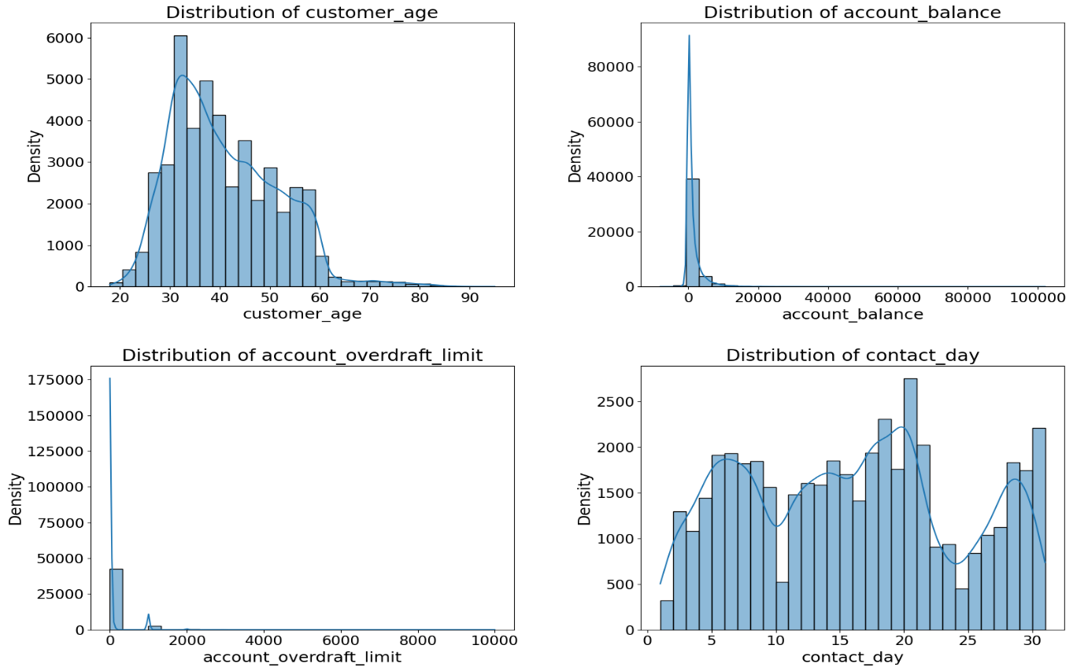
Figure 2:Numerical variables histogram

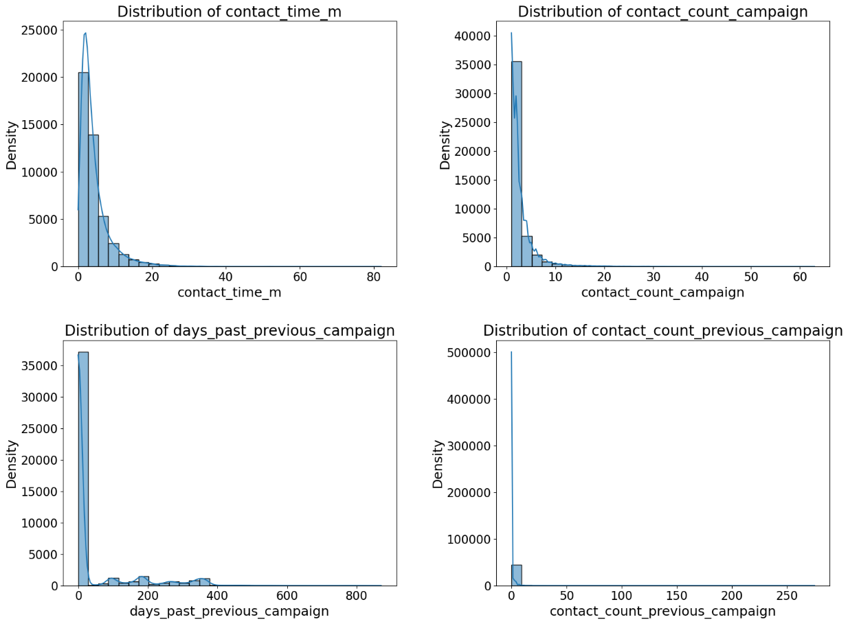
Figure 3:Numerical variables histogram

- Age: The age distribution is right-skewed, with most customers aged 20 to 60, peaking around 30-35, and fewer customers over 60.
- Account Balance: The distribution is highly right-skewed, with most customers having low balances and a few with significantly higher balances, creating a long right tail.
- Account Overdraft Limit: The overdraft limit is also right skewed, with most customers having minimal limits and a few with much higher ones.
- Contact Day: Contact days are nearly uniformly distributed across the month, with slight peaks on specific days, indicating potential contact patterns.
- Contact Time (Seconds and Minutes): Both in seconds and minutes, contact time is sharply right skewed, with most contacts being brief and only a few lasting longer.
- Contact Count per Campaign: This variable shows right-skewness, with most customers contacted only a few times and very few contacted multiple times.
- Days Since Previous Campaign: The distribution is right-skewed, with most customers having a short interval since the last campaign and a few with much longer gaps.
- Previous Campaign Contact Count: Extremely right skewed, with most customers having few or no previous contacts, while a small number have been contacted many times.

Visualization of categorical variables
            - Bar charts
The following visualizations offer a detailed graphical representation of categorical features, providing information on the counts of the variables and aiding in uncovering informative patterns.

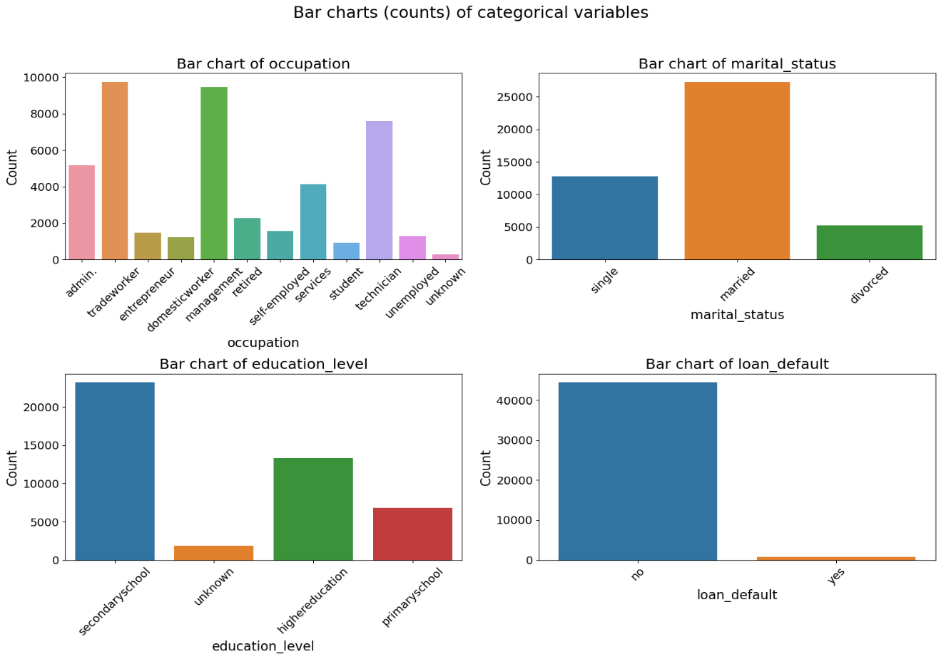
Figure 4: Categorical variables bar chart

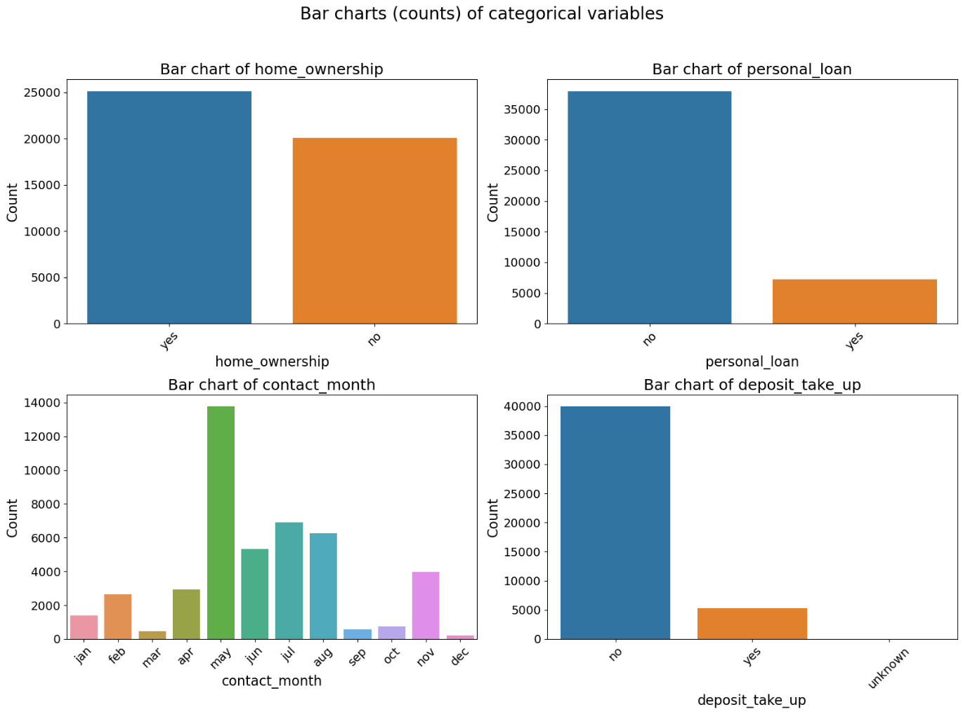
Figure 5:Categorical variables bar charts

The bar charts illustrate that most of the bank's customers are married, employed as technicians or managers, and have attained a secondary education level. The vast majority do not have personal debts or a history of loan defaults. There are slightly more customers who own property than those who do not. The bank reaches out to the highest number of customers in May. Overall, more individuals decline the long-term deposit proposals than agree to them
            - Stacked bar charts:
The stacked bar chart below is used to uncover the relationship between customer age and deposit-take-up, as well as compare deposit take-up across different age groups.
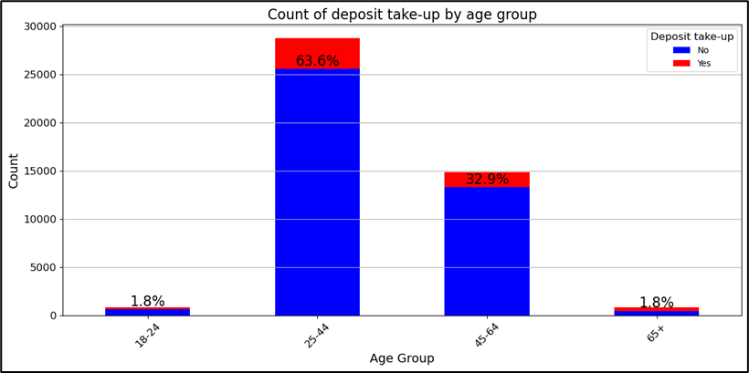
Figure 6: Deposit-take-up by age group stacked bar chart

The customer age variable had an unrealistic age range, of 0 to 150 years, which was adjusted to a more reasonable age range of 18 to 100 years, by filtering out the other ages. The age of the customers was then divided into four distinct groups, as binning has been useful in previous studies for preparing predictors for binary classification, (Lund, 2016). The rationale for the age group cut-offs was according to Donlad Super's development self-concept, (Super D.E, 2012). The age categories '18-24', '25-44', '45-64', '65+' represent the stages of exploration/career building, establishment, maintenance, and disengagement/retirement, respectively. The age group with the highest number of deposit take-ups is 25-44 and 45–64. However, within these ranges, most individuals declined the deposit offer, as indicated by the blue bars. Across all age groups, only a small percentage of people accepted the deposit offer, represented by the red bars. The 18–24 and 65+ age groups exhibited both a low overall population and a low rate of deposit take-up.

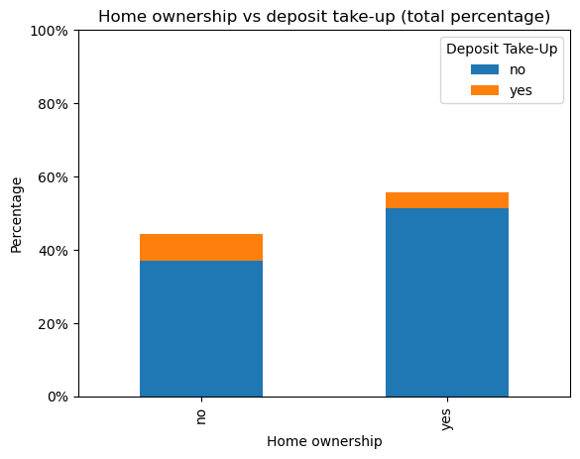
The stacked bar chart below compares deposit take-up between homeowners and non-homeowners.
Figure 7: Deposit-take-up by home ownership group stacked bar char

Non-homeowners, make up 40% of the total, with a small portion opting to take up a deposit. For those who do own a home, they make up about 60% of the total, and similarly, only a small fraction has taken up a deposit. Across both groups, majority, have not opted for a deposit.

The stacked bar chart below compares deposit take-up across different months (January to December).
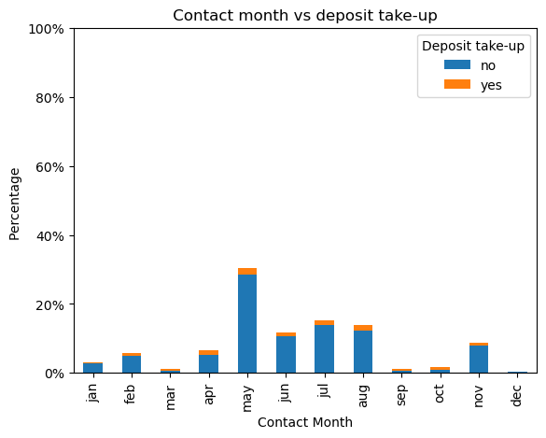
Figure 8: Deposit-take-up by contact month group stacked bar char

May has approximately 25% of contacts, with a legible percentage of deposit up-takes. Other months, such as July, August, and October, show moderate levels of contact but still relatively small proportions of deposit take-up. Most months have minimal contact and very few deposit take-ups, March, February, and December have almost no contact activity.

The stacked bar chart below shows the percentage of marital status in relation to deposit take-up as and compares different marital status against deposit take-up.
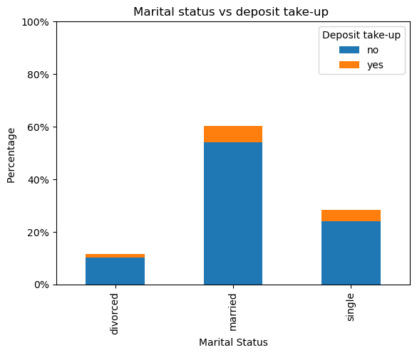
Figure 9: Marital status vs deposit take-up
Most people are married, making up approximately 60% of the total, with few opting to uptake a long-term deposit. The percentage of single people is lower approximately 25%, and their rate of deposit take-up is slightly greater. Divorced people make up the smallest group approximately 10% of the total and very few of them have deposited money. Most individuals across all marital categories have chosen not to make a deposit.

Pearson correlation analysis
This part of exploratory data analysis (EDA) examines the Pearson correlation between the variables, checks for multicollinearity and identifies potential redundant variables to be dealt with.
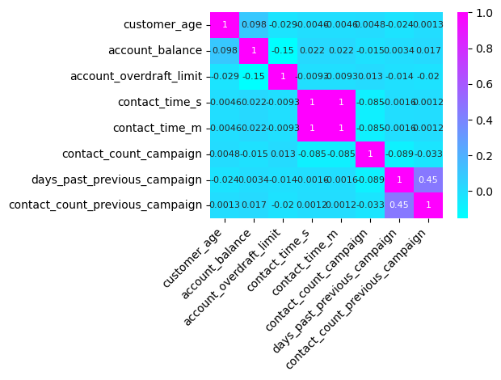
Figure 10: Pearson correlation matrix

There is a perfect correlation of 1 between contact time (seconds and minutes). Since they provide the same information about the data, it would be useful to reduce it to one variable to avoid redundancy. The rest of the variables exhibit weak correlations, with the days past the previous campaign and contact count in the previous campaign being moderately positive with a correlation of 0.45.

Outliers
This section identifies outliers in the dataset and assesses their impact on the analysis, followed by appropriate treatment.
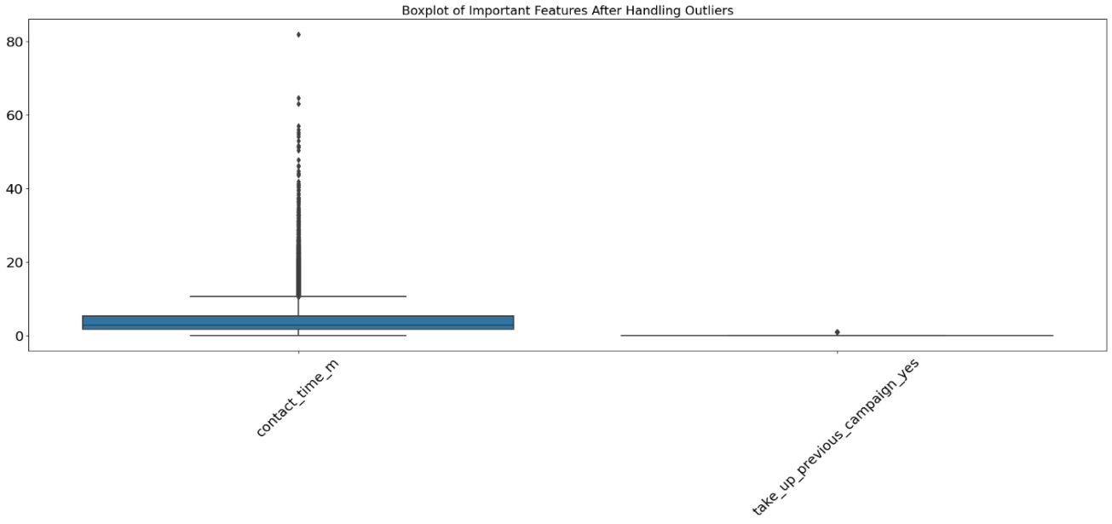
Figure 11: Outliers box plots

- Outlier detection: Outliers were identified in contact time (minutes) and customers who responded positively, indicating 'yes' to the take-up on the previous campaign using standard statistical techniques, such as the interquartile range (IQR) and visualizations (e.g., box plots), to highlight values significantly deviating from the median.
- Outlier treatment: Winsorization and robust scaling were applied, with winsorization capping the extreme values to a specified percentile (lower quantile = 0.01 and upper quantile = 0.99) and robust scaling adjusting the data by the interquartile range to reduce the influence of outliers.

Pie charts of unbalanced and balanced data
The pie charts visually represent the distribution of the positive class and the negative class, showing how each category contributes to the total of the target.

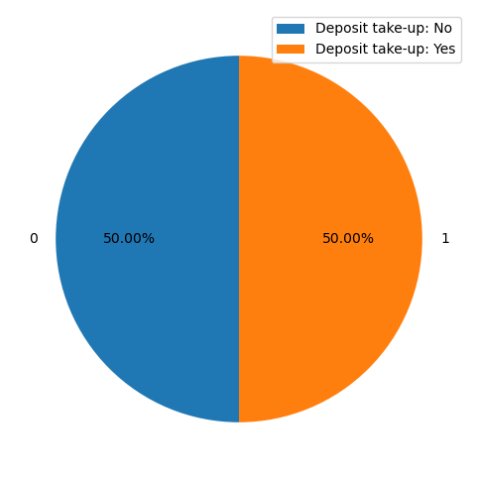
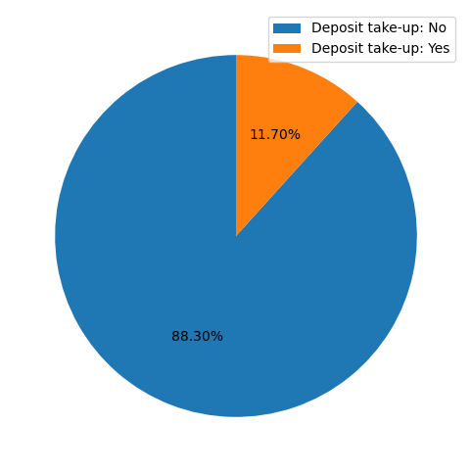
Figure 13: Balanced data pie chart

Figure 12: Unbalanced data pie chart

The SMOTE technique was applied to the training dataset consisting of 31647 entries and 34 variables, to make the minority class of deposit take-up 'yes', equal to the majority class 'no'. As a result, there are now 27919 entries and 34 variables for both classes, i.e., 55838 entries in total. This addresses the class imbalance and prevents the models from being biased towards the majority class 'no'.
  - Statistical analysis
This section presents and discusses the performance of LR (logistic regression) and DT(decision tree), as well as highlights the key features in the prediction of deposit take-up.
    - Logistic regression:
Logistic regression
Overall accuracy | 79%
Training accuracy | 79%
Test accuracy | 79%
ROC AUC score | 0.89
Classification report
Class 0 performance | Class 1 performance
96% precision | 32% precision
80% recall | 73% recall
87% f1-score | 45% f1-score
Averages
Macro Average | Weighted Average
64% precision | 88% precision
77% recall | 79% recall
66% f1-score | 82 f1-score
LR shows an accuracy 79%. The precision and recall for class 0 and class 1 are (96%, 80%) and (32%, 73%) respectively with a (87%, 45%) f1-score. This indicates that the model performs well on class 0 but struggles with class 1, especially in terms of precision. This is also reflected in the F1-score of 45%, indicating that the model’s ability to balance precision and recall for class 1 is inadequate. The ROC index of 89% reveals that the model has high predictive accuracy.
Table 2: Performance metrics for logistic regression model
The table below provides the classification report of the LR model and gives insight into its performance.

The plot below highlights the influence of each variable on the probability of a deposit take-up by showing the significant variable coefficients from the LR model.
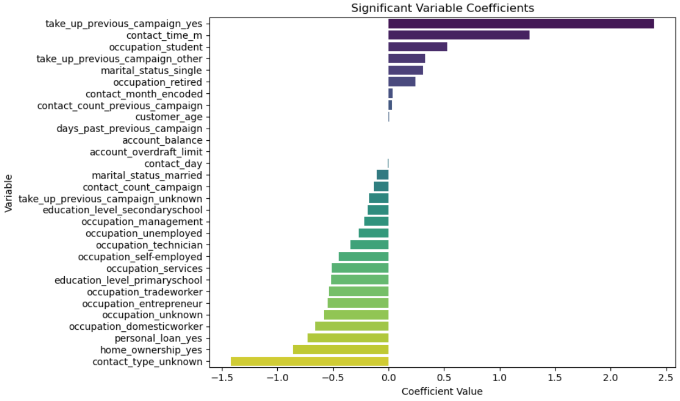
Figure 14: Logistic Regression model significant variables
At a significance level of 0.05, LR model suggests the following influences by predictors, in order of importance:
- Factors that increase the likelihood of a positive take-up include a previous campaign participation, contact time in minutes, being a student, and being single.
- Factors that decrease the likelihood of no take-up include home ownership, having a personal loan, working as a domestic worker, or in other occupations such as entrepreneur or trade worker.

    - Decision tree:
The DT model performance before cross-validation indicated overfitting, as evidenced by the perfect training accuracy of 1.0 and test accuracy of 0.87. This overfitting suggests that the model was too complex, capturing noise in the training data rather than generalizing well to unseen data. After cross-validation, the model's training and testing accuracy decreased to 90%. This adjustment shows a better balance between training and test accuracy, with reduced overfitting and improved generalization to unseen data.

The table below provides the classification report of the DT model and gives insight into its performance.
Decision tree
Overall accuracy | 90%
Training accuracy | 90%
Test accuracy | 90%
ROC AUC score | 0.86
Classification report
Class 0 performance | Class 1 performance
92% precision | 64% precision
97% recall | 39% recall
95% f1-score | 49% f1-score
Average
Macro Average | Weighted
78% precision | 89% precision
68% recall | 90% recall
72% f1-score | 89% f1-score
Table 3: Performance metrics for decision tree model

The ROC AUC score of 86% further supports the model’s ability to distinguish between the two classes. The classification report reveals that for predicting the class 1, the model has a precision rate of 64% and a recall rate of 39%, indicating its inability to effectively identify the customers who will make deposits. For class 0, the precision increases to 92%, while the recall is 97%. Overall, the classification report reveals that the decision tree model performs slightly better for class 1 (depositors) than for class 0 (non-depositors).
The plot below shows the significant variables according to the DT model.
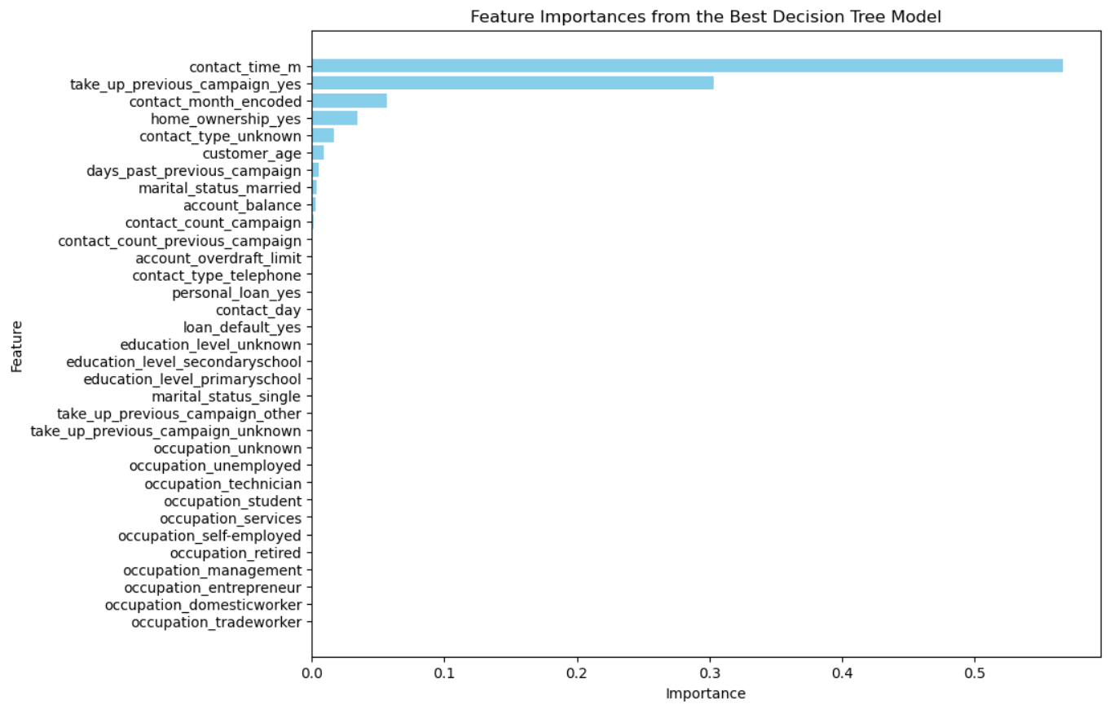
Figure 15: Decision tree model significant variables
The feature importance analysis highlights that contact time and previous campaign participation are key predictors in the model. These findings suggest that customer interactions, successful previous campaigns and timing play significant roles in predicting whether customers will accept the deposit offer or not.
Both the DT and LR perform well for class 0 but struggle for class 1. LR does a better job at capturing true positives (higher recall) in class 1 but suffers from low precision. Additionally, DT has better precision for Class 1 but misses many true positives.

Recommendations
Based on the analysis and findings of this study, several key actions are recommended to improve the model performance and ensure data security. These recommendations focus on utilising advanced tools, optimizing processes and ensuring compliance with relevant data privacy regulations.
- Exploring more advanced statistical techniques: Introducing other advanced methods such as Random Forest to aid accuracy and performance.
- Use other software for enhanced modelling: While this study used Python, incorporating additional tools can further enhance the analysis. Platforms such as SAS, PowerBI, Google Cloud AI Platform, or R offer several advantages. They provide greater scalability and enable faster deployment of models.
- Optimize contact timing: The study findings reveal that contact time significantly influences the success of telemarketing efforts. Banks should leverage predictive analytics to identify the optimal times for contacting customers, thereby maximizing the likelihood of a positive response. Implementing a data-driven approach to contact timing will enhance the efficiency of telemarketing operations.
- Continuous monitoring and updating of models: As customer behaviour and market dynamics evolve, it is essential to regularly monitor the performance of predictive models and update them with new data. Continuous model validation and recalibration will help maintain the accuracy and relevance of predictions, ensuring sustained improvements in telemarketing success.
- Balance model complexity and interpretability: While more complex models may offer superior predictive accuracy, their interpretability is crucial for practical application in business decision-making. The use of decision tree models, which balance accuracy with interpretability, is recommended. For more complex models, interpretability tools such as SHAP (Shapley Additive Explanations) should be utilized to explain model outputs effectively.
- Data privacy and security enhancements: As predictive models rely on customer data, ensuring compliance with data privacy regulations like protection of personal information act (POPIA) for South Africa is critical. Banks should implement strong data encryption and anonymization practices to protect customer information while continuing to leverage advanced analytics.

Conclusion
By applying logistic regression and decision tree models, this research aimed to enhance customer targeting and optimize telemarketing strategies. Key predictors include contact time, successful previous campaign engagements, and contact type. The analysis suggests that customers who have had longer contact times and previous successful interactions are more likely to accept a deposit offer.
The models provide insights for the bank's telemarketing strategies. By prioritizing customers with a high likelihood of deposit take-up, the bank can optimize resources, reduce costs, and improve conversion rates. Timing and consistency in customer interactions are critical, highlighting the need to align campaigns with customer availability and past behaviours.
Several anomalies were discovered in the data, such as unrealistic age values (ranging from 0 to 150 years) and negative campaign intervals. These were corrected during the data cleaning process. The initial decision tree model showed overfitting, which was characterized by good performance on training data but poor generalization to new data. To address this, 5-fold cross-validation was used, which divided the dataset into five subsets and thoroughly assessed the model's performance across different parts of the data. This process helped find the best model configuration, which reduced the tree’s complexity and improved generalization.
It is recommended that other advanced models are built to improve accuracy. Integrating these predictive models into the bank's CRM systems (hypothetically) will enable real-time, data-driven decision-making. This integration is expected to improve customer satisfaction, reduce unnecessary contact attempts, and increase the uptake of long-term deposits.

References
- Dincer, H., Hacioglu, U., Tatoglu, E., & Delen, D. (2019). Developing a hybrid analytics approach to measure the efficiency of deposit banks. Journal of Business Research, 104. https://www.sciencedirect.com/science/article/abs/pii/S0148296319303959?via%3Dihub
- McAfee, A., & Brynjolfsson, E. (2012). Big Data: The Management Revolution - Harvard Business Review. Harvard Business Review, October. https://pubmed.ncbi.nlm.nih.gov/23074865/
- Neysiani, B. S., Soltani, N., & Ghezelbash, S. (2016). A framework for improving find best marketing targets using a hybrid genetic algorithm and neural networks. Conference Proceedings of 2015 2nd International Conference on Knowledge-Based Engineering and Innovation, KBEI 2015. https://ieeexplore.ieee.org/document/7436136
- Palaniappan, S., Mustapha, A., Foozy, C. F. M., & Atan, R. (2017). Customer profiling using classification approach for bank telemarketing. International Journal on Informatics Visualization, 1(4–2). https://doi.org/10.30630/joiv.1.4-2.68
- Yan, C., Li, M., & Liu, W. (2020). Prediction of bank telephone marketing results based on improved whale algorithms optimizing S_Kohonen network. Applied Soft Computing Journal, 92. https://www.sciencedirect.com/science/article/abs/pii/S156849462030199X?via%3Dihub
- Hosseni, S. (2021). A decision support system based on machined learned Bayesian network for predicting successful direct sales marketing. https://www.tandfonline.com/doi/abs/10.1080/23270012.2021.1897956

- Witten, I. H., Frank, E., & Geller, J. (2002). Data Mining: Practical Machine Learning Tools and Techniques with Java Implementations. SIGMOD Record, 31(1). https://doi.org/10.1145/507338.507355
- Ilham, A., Khikmah, L., Indra, Ulumuddin, & Bagus Ary Indra Iswara, I. (2019). Long-term deposits prediction: A comparative framework of classification model for predict the success of bank telemarketing. Journal of Physics: Conference Series, 1175(1). https://doi.org/10.1088/1742-6596/1175/1/012035
- Lu, X. Y., Chu, X. Q., Chen, M. H., Chang, P. C., & Chen, S. H. (2016). Artificial immune network with feature selection for bank term deposit recommendation. Journal of Intelligent Information Systems, 47(2). https://doi.org/10.1007/s10844-016-0399-2
- Tekouabou, S. C. K., Cherif, W., & Silkan, H. (2019). A data modelling approach for classification problems: Application to bank telemarketing prediction. ACM International Conference Proceeding Series, Part F148154. https://doi.org/10.1145/3320326.3320389
- Vajiramedhin, C., & Suebsing, A. (2014). Feature selection with data balancing for prediction of bank telemarketing. Applied Mathematical Sciences, 8(113–116). https://doi.org/10.12988/ams.2014.47222

- Mehrabi, N., Morstatter, F., Saxena, N., Lerman, K., & Galstyan, A. (2021). A survey on bias and fairness in machine learning. ACM Computing Surveys, 54(6). A Survey on Bias and Fairness in Machine Learning.https://dl.acm.org/doi/10.1145/3457607
- Moro, S., Cortez, P., & Rita, P. (2014). A data-driven approach to predict the success of bank telemarketing. Decision Support Systems, 62. A data-driven approach to predict the success of bank telemarketing – ScienceDirect.https://www.sciencedirect.com/science/article/abs/pii/S016792361400061X
- Guidotti, R., Monreale, A., Ruggieri, S., Turini, F., Giannotti, F., & Pedreschi, D. (2018). A survey of methods for explaining black-box models. ACM Computing Surveys, 51(5). A Survey of Methods for Explaining Black Box Models. https://dl.acm.org/doi/10.1145/3236009
- Ribeiro, M. T., Singh, S., & Guestrin, C. (2016). "Why should I trust you?" Explaining the predictions of any classifier. Proceedings of the 22nd ACM SIGKDD International Conference on Knowledge Discovery and Data Mining. 1602.04938.https://arxiv.org/abs/1602.04938
- Boenisch, F. (2019). Differential Privacy: General Survey and Analysis of Practicability in the Context of Machine Learning. 2019_Boenisch_MSc.pdf.https://www.mi.fu-berlin.de/inf/groups/ag-idm/theseses/2019_Boenisch_MSc.pdf
- Burnaev, E., Erofeev, P., & Papanov, A. (2015). Influence of resampling on accuracy of imbalanced classification. Eighth International Conference on Machine Vision (ICMV 2015), 9875. https://www.spiedigitallibrary.org/conference-proceedings-of-spie/9875/1/Influence-of-resampling-on-accuracy-of-imbalanced-classification/10.1117/12.2228523.short
- Lund, B. (2016). Weight of Evidence Coding and Binning of Predictors in Logistic Regression. Mwsug, 2010.https://www.lexjansen.com/sesug/2017/SD-69.pdf
- Super D.E. (2012). Donald Super Developmental self-concept. Jurnal Manajemen, 20(2).
https://www.careers.govt.nz/assets/pages/docs/career-theory-model-super.pdf
- Vrigazova, B. (2021). The Proportion for Splitting Data into Training and Test Set for the Bootstrap in Classification Problems. Business Systems Research, 12(1). https://hrcak.srce.hr/ojs/index.php/bsr/article/view/17347/9337

Appendix

Codes
This subsection of the appendix contains detailed codes used in each section of the analysis.

Data preprocessing
Check for data errors:
#Read in the data
Bank_Data = pd.read_excel('C:\\Users\\deemp\\OneDrive\\Attachments\\STA 761\\Bank_Data.xlsx')
# Output of the data
Bank_Data.head()

#Check the number of missing values
print("Missing records",Bank_Data.isnull().sum())

#Check for duplicated entries
num_duplicates = Bank_Data.duplicated().sum()
print(f"Number of duplicated records: {num_duplicates}")

Remedies for data errors:
#Remove duplicated entries
Bank_Data_2 = Bank_Data.drop_duplicates()

#Handle unrealistic customer age range
# Define realistic age range (18 to 100)
min_age = 18
max_age = 100

# Filter out rows with unrealistic customer_age values
Bank_Data_3 = Bank_Data_2[(Bank_Data_2['customer_age'] >= min_age) & (Bank_Data_2['customer_age'] <= max_age)]

#Correcting the months to be written in the same way
# Replace 'june' with 'jun'
Bank_Data_3['contact_month'] = Bank_Data_3['contact_month'].replace('june', 'jun')

#Drop customer number
Bank_Data_5 = Bank_Data_3.drop(columns=['customer_number'])

#Deal with redundancy(drop contact time(s)
Bank_Data_5.drop(['contact_time_s' ], axis=1, inplace=True)

#Outlier treatmemt
# Function to apply Winsorization to a pandas series
def winsorize_series(series, lower_quantile=0.01, upper_quantile=0.99):
lower_limit = series.quantile(lower_quantile)
upper_limit = series.quantile(upper_quantile)
return np.clip(series, lower_limit, upper_limit)
# Apply Winsorization to the selected important features
for col in important_features:
Bank_Data_5[col] = winsorize_series(Bank_Data_5[col])
# Apply Robust Scaling to handle outliers effectively
scaler = RobustScaler()
Bank_Data_5[important_features] = scaler.fit_transform(Bank_Data_5[important_features])

Visualisations

Visualisations numerical variables:
# Select numerical columns
numerical_columns = Bank_Data_5.select_dtypes(include=['float64', 'int64']).columns

# Set up the number of rows and columns for the plots
num_plots = len(numerical_columns)
num_rows = (num_plots // 3) + (num_plots % 3 > 0)

# Create the subplots
plt.figure(figsize=(18, num_rows * 5))
for i, column in enumerate(numerical_columns, 1):
plt.subplot(num_rows, 3, i)
sns.histplot(Bank_Data_5[column], kde=True, bins=30)
plt.title(f'Distribution of {column}')
plt.xlabel(column)
plt.ylabel('Density')

# Adjust layout for better spacing
plt.tight_layout()
plt.show()
Visualizations of categorical variables:

# Barcharts
#Create list of categorical columns
categorical_columns = [
'occupation', 'marital_status', 'education_level', 'loan_default',
'home_ownership', 'personal_loan', 'contact_month', 'deposit_take_up'
]

# Create subplots
n_cols = 3 # Number of columns in the grid
n_rows = (len(categorical_columns) + n_cols - 1) // n_cols # Number of rows needed
fig, axes = plt.subplots(n_rows, n_cols, figsize=(20, 5 * n_rows), squeeze=False)

# Add a title to the entire figure
fig.suptitle('Barplots (counts) of categorical variables', fontsize=16)

# Plot each categorical variable
for i, column in enumerate(categorical_columns):
ax = axes[i // n_cols, i % n_cols]
if column in Bank_Data_5.columns:
sns.countplot(x=column, data=Bank_Data_5, ax=ax)
ax.set_title(f'Bar Plot of {column}')
ax.tick_params(axis='x', rotation=45)
else:
ax.text(0.5, 0.5, f"'{column}' not found", ha='center', va='center')

# Adjust layout
plt.tight_layout(rect=[0, 0, 1, 0.95])

# Output
plt.show()

#Stacked bar chart(Deposit take-up by age)
# Create bins for customer age
bins = [18, 40, 60, 80, 100]
bin_labels = ['18-40', '41-60', '61-80', '81-100'] # Corrected to be a list

# Bin the age data
Bank_Data_5['age_group'] = pd.cut(Bank_Data_5['customer_age'], bins=bins, labels=bin_labels, right=False)

# Count occurrences of deposit_take_up for each age group
count_age_deposit = pd.crosstab(Bank_Data_5['age_group'], Bank_Data_5['deposit_take_up'])

# Plot the data
count_age_deposit.plot(kind='bar', stacked=True, figsize=(12, 6), color=['blue', 'red']) # Fixed color argument

# Customize the plot
plt.xlabel('Age Group')
plt.ylabel('Count')
plt.title('Count of Deposit Take-Up by Age Group')
plt.xticks(rotation=45)
plt.legend(title='Deposit Take-Up', labels=['No', 'Yes'])
plt.grid(axis='y')
plt.tight_layout()

# Display the plot
plt.show()

Pearson correlation heatmap:
# Create list of numerical columns
numerical_columns = [
'customer_age', 'account_balance', 'account_overdraft_limit',
'contact_time_s', 'contact_time_m', 'contact_count_campaign',
'days_past_previous_campaign', 'contact_count_previous_campaign']

# Correlation matrix
correlation_matrix = Bank_Data_5[numerical_columns].corr()
sns.heatmap(correlation_matrix, annot=True, cmap='cool')
plt.show()

Outliers:
# Visualize outliers before handling them
dummy_data_before = Bank_Data_5[important_features]
plt.figure(figsize=(20, 10))
plt.title('Boxplot of Important Features Before Handling Outliers')
sns.boxplot(data=dummy_data_before)
plt.xticks(rotation=45)
plt.show()

Feature engineering and data balancing
Encoding:
# Encode categorical variables
categorical_columns = [
'occupation','take_up_previous_campaign',
'marital_status',
'education_level',
'loan_default',
'home_ownership',
'personal_loan','contact_type']

# Create dummy variables
Bank_Data_5= pd.get_dummies(Bank_Data_5, columns=categorical_columns, drop_first=True)

# For binary target use label encoding
Bank_Data_5['deposit_take_up'] = Bank_Data_5['deposit_take_up'].map({'no': 0, 'yes': 1})

#Encoding the months
from sklearn.preprocessing import OrdinalEncoder
#Create an instance of OrdinalEncoder
encoder = OrdinalEncoder()

# Fit and transform the 'contact_month' column(ordered )
Bank_Data_5['contact_month_encoded'] = encoder.fit_transform(Bank_Data_5[['contact_month']])

# Drop the 'contact_month' column
Bank_Data_5 = Bank_Data_5.drop(columns=['contact_month'])

Model building
Splitting data into train and test datasets:
from sklearn.model_selection import train_test_split
# Define the target variable and predictor variables
X = bank_resampled.drop(['deposit_take_up'], axis=1)
y = bank_resampled['deposit_take_up']

X_train, X_test, y_train, y_test = train_test_split(bank_resampled.drop('deposit_take_up',axis=1),
bank_resampled['deposit_take_up'], test_size=0.30,
random_state=101)

Data balancing with oversampling:
#Synthetic Minority Over-sampling Technique
from imblearn import over_sampling
from imblearn.over_sampling import RandomOverSampler

# Apply RandomOverSampler to balance the classes

# Apply RandomOverSampler to the training data only
ros = RandomOverSampler(random_state=42)
X_train_resampled, y_train_resampled = ros.fit_resample(X_train, y_train)

# Combine the resampled features and target into a DataFrame for the training set
train_resampled = pd.concat([pd.DataFrame(X_train_resampled), pd.DataFrame(y_train_resampled)], axis=1)
#Pie chart of balanced data
train_resampled_count = train_resampled['deposit_take_up'].value_counts().to_list()
train_resampled_labels = train_resampled['deposit_take_up'].value_counts().index

plt.pie(train_resampled_count, labels = train_resampled_labels, autopct = '%.2f%%', startangle=90)
fig = plt.gcf()
fig.set_size_inches(6, 6)
Model 1: Logistic Regression
from sklearn.linear_model import LogisticRegression

logmodel = LogisticRegression()
# Fit the model using the resampled training data
M = logmodel.fit(X_train_resampled, y_train_resampled)
predictions = logmodel.predict(X_test)

import statsmodels.api as sm
glm = sm.GLM(y_train,
X_train,
family=sm.families.Binomial())
results = glm.fit()
print(results.summary())

#Logistic Regression Validation and Evaluation:
from sklearn.metrics import classification_report
from sklearn import metrics
from sklearn.metrics import accuracy_score
#Classification report
print(classification_report(y_test,predictions))
print("The accuracy of the model is: ", metrics.accuracy_score(predictions,y_test)*100, "%")

# Significant variable plot
Get the significant coefficients
significant_coefficients = results.params[significant_vars] # Extract coefficients for significant variables

# Create a dataframe for easier plotting
coeff_df = pd.DataFrame({
'Variable': significant_vars,
'Coefficient': significant_coefficients
})

# Sort coefficients for better visualization
coeff_df = coeff_df.sort_values(by='Coefficient', ascending=False)

# Plot the coefficients
plt.figure(figsize=(10, 6))
sns.barplot(x='Coefficient', y='Variable', data=coeff_df, palette='viridis')
plt.title('Significant Variable Coefficients')
plt.xlabel('Coefficient Value')
plt.ylabel('Variable')
plt.tight_layout()
plt.show()

#Evaluation metrics
print(classification_report(y_test,predictions))
print("The accuracy of the model is: ", metrics.accuracy_score(predictions,y_test)*100, "%")

#Evaluation using ROC indexfrom sklearn.metrics import accuracy_score, roc_auc_score
from sklearn.metrics import accuracy_score, roc_auc_score
# Get the probability scores for the positive class from the best logistic regression model
y_prob_glm = best_model.predict(X_test)

# Calculate the ROC AUC score
roc_auc_glm = roc_auc_score(y_test, y_prob_glm)
print(f'ROC AUC Score (GLM): {roc_auc_glm:.2f}')

# Refit the best model on the entire training dataset
best_glm_final = sm.GLM(y_train, X_train, family=sm.families.Binomial())
best_results_final = best_glm_final.fit()

# Print the summary of the best model
print(best_results_final.summary())
Model 2:Decision tree:
from sklearn.tree import DecisionTreeClassifier
from sklearn.metrics import accuracy_score
from sklearn.datasets import load_iris
from sklearn.model_selection import cross_val_score, GridSearchCV
#Train the decision tree classifier
clf = DecisionTreeClassifier()
# Fit the model with the resampled training data
clf.fit(X_train_resampled, y_train_resampled)
#Decision tree validation and evaluation:
# Predictions
y_pred_train = clf.predict(X_train_resampled)
y_pred_test = clf.predict(X_test)

# Evaluate model
train_accuracy = accuracy_score(y_train_resampled, y_pred_train)
test_accuracy = accuracy_score(y_test, y_pred_test)

print("Training Accuracy:", train_accuracy)
print("Testing Accuracy:", test_accuracy)
#Reduce overfitting with k-fold cross-validation
# Initialize the DecisionTreeClassifier
clf = DecisionTreeClassifier()
print("\nTest Precision:", test_precision)
print("Test Recall:", test_recall)
print("Test F1-Score:", test_f1)

# Use cross-validation to evaluate the initial model
#Reduce overfitting with k-fold cross-validation
# Initialize the DecisionTreeClassifier
clf = DecisionTreeClassifier()

from sklearn.tree import DecisionTreeClassifier
from sklearn.model_selection import GridSearchCV, cross_val_score

# Initialize the DecisionTreeClassifier
clf = DecisionTreeClassifier()

# Use cross-validation to evaluate the initial model
cv_scores = cross_val_score(clf, X, y, cv=5)
print(f"Initial CV scores: {cv_scores}")
print(f"Mean CV score: {cv_scores.mean()}")

# Set up a parameter grid to tune hyperparameters for pruning
param_grid = {
'max_depth': [3, 5, 7, 10],
'min_samples_split': [2, 5, 10],
'min_samples_leaf': [1, 2, 5]
}

# Perform grid search with cross-validation
grid_search = GridSearchCV(clf, param_grid, cv=5, scoring='accuracy')
grid_search.fit(X, y)

# Get the best model after grid search
best_clf = grid_search.best_estimator_
print(f"Best parameters: {grid_search.best_params_}")

# Evaluate the best model using cross-validation
best_cv_scores = cross_val_score(best_clf, X, y, cv=5)
print(f"Best model CV scores: {best_cv_scores}")
print(f"Mean best model CV score: {best_cv_scores.mean()}")

# Fit the best model on the entire dataset (optional, depending on the use case)
# Predict on the training data
y_train_pred = best_clf.predict(X_train_resampled)

# Calculate the accuracy on the training data
train_accuracy = accuracy_score(y_train_resampled, y_train_pred)
print(f"Training Accuracy: {train_accuracy}")

# Predict on the test data
y_test_pred = best_clf.predict(X_test)

# Calculate the accuracy on the test data
test_accuracy = accuracy_score(y_test, y_test_pred)
print(f"Test Accuracy: {test_accuracy}")
# Make predictions on the test set
y_pred_test = best_clf.predict(X_test)

# Calculate evaluation metrics
test_accuracy = accuracy_score(y_test, y_pred_test)
test_precision = precision_score(y_test, y_pred_test)
test_recall = recall_score(y_test, y_pred_test)
test_f1 = f1_score(y_test, y_pred_test)

# Print evaluation metrics
print("Test Accuracy:", test_accuracy)
print("Test Precision:", test_precision)
print("Test Recall:", test_recall)
print("Test F1-Score:", test_f1)

# Optional: Full classification report
print("\nClassification Report for Test Set:")
print(classification_report(y_test, y_pred_test))

#Feature importance
X = Bank_Data_5.drop(columns=['deposit_take_up'])
feature_names = X.columns

# Extract feature importances from the best model
feature_importances = best_clf.feature_importances_

# Create a DataFrame to organize and sort the feature importances
importance_df = pd.DataFrame({
'Feature': feature_names,
'Importance': feature_importances
})

# Sort the DataFrame by importance in descending order
importance_df = importance_df.sort_values(by='Importance', ascending=False)

# Display the feature importances
print(importance_df)

# Plot the feature importances
plt.figure(figsize=(10, 8))
plt.barh(importance_df['Feature'], importance_df['Importance'], color='skyblue')
plt.xlabel('Importance')
plt.ylabel('Feature')
plt.title('Feature Importances from the Best Decision Tree Model')
plt.gca().invert_yaxis() # To have the most important feature at the top
plt.show()

# Precision of the cross validated model
#Make predictions using the best decision tree model
predictions = best_clf.predict(X_test)

# Import necessary metrics from sklearn
from sklearn.metrics import classification_report
from sklearn import metrics
from sklearn.metrics import accuracy_score

# Print the classification report for precision, recall, F1-score, and support
print(classification_report(y_test, predictions))

#Evaluation using ROC Index
from sklearn.metrics import roc_auc_score
from sklearn.metrics import roc_curve
import matplotlib.pyplot as plt

# Get the probability scores for the positive class
y_prob = best_clf.predict_proba(X_test)[:, 1]

# Calculate the ROC AUC score
roc_auc = roc_auc_score(y_test, y_prob)
print(f'ROC AUC Score: {roc_auc:.2f}')

Column dimension table
This table provides a description and the number of variables remaining after data cleaning.
No. | Variable name | Data type | Description
1 | customer_age | int64 | Age of the customer in years
2 | occupation | object | Occupation categories:  "administrator","unknown","unemployed", etc.
3 | marital_status | object | Marital status categories: "married", "divorced", "single"
4 | education_level | object | Education level categories: "unknown", "secondary school", "primary school", "higher education"
5 | loan_default | object | Whether the client has a credit account in default ("yes" or "no")
6 | account_balance | int64 | Bank account balance: average yearly balance in Rand
7 | account_overdraft_limit | int64 | Bank account overdraft limit: average yearly limit in Rand
8 | home_ownership | object | Whether the client owns a home ("yes" or "no")
9 | personal_loan | object | Whether the client has a personal loan ("yes" or "no")
10 | contact_type | object | Communication type categories: "unknown", "telephone", or "cellular"
11 | contact_day | int64 | Last contact day of the month during this campaign
12 | contact_month | object | Last contact month during the campaign ("jan", "feb", ..., "dec")
13 | contact_time_m | float64 | Last contact time during this campaign, in minutes
14 | contact_count_campaign | int64 | Number of contacts made during this campaign for this client
15 | days_past_previous_campaign | int64 | Number of days that passed since the client was last contacted from a previous campaign
16 | contact_count_previous_campaign | int64 | Number of contacts made in previous campaigns
17 | take_up_previous_campaign | object | Outcome categories of the previous marketing campaign: "unknown", "other", "no", "yes"
18 | deposit_take_up | object | Whether the client has taken up a term deposit account ("yes" or "no")
19 | age_group | category | Grouping of customer ages into categories: "18-40", "41-60", "61+"
Table 4: Cleaned data variables

